LAB 7
TASK1:
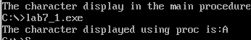
TASK2:
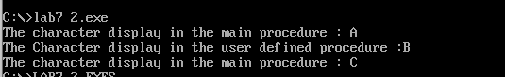
TASK3:
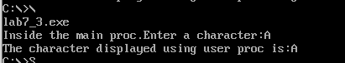
TASK4:
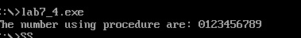
TASK5:

TASK6:
TASK7:

